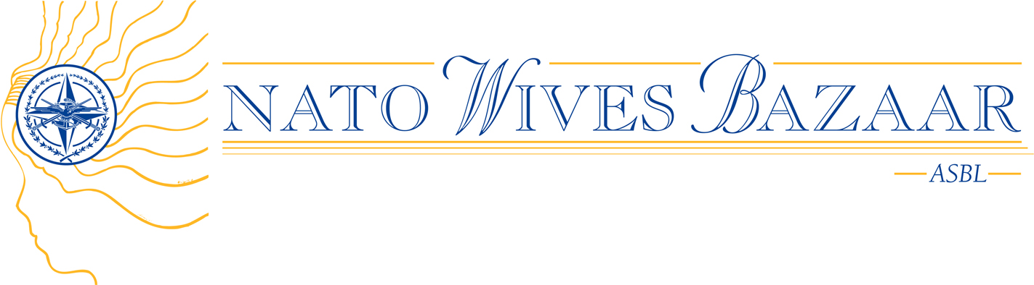

ORGANIZATION OVERVIEW

2009

OVERVIEW
Started in 1968, this annual charity fundraiser has been the major social event of the year for the international NATO community. It is held on the third Sunday of November at NATO Headquarters in Brussels, Belgium, with the support and patronage of the NATO Secretary General. Other event patrons include NATO’s Deputy Secretary General, the Chairman of NATO’s Military Committee and their spouses. The Bazaar is organized by volunteers from the member nations of NATO and is attended by over 5000 people each year.

On 6 April 2005, the NATO Wives Bazaar became a non-profit association in Belgium, officially registered as an ASBL, with the following objectives:
- To organize activities and social events with the aim of raising money for Belgium and international charities.
- To bring together spouses and partners of NATO military personnel in order to foster friendship within its international community.

FUND RAISING ACTIVITIES
The major event of the organization is the annual Bazaar. The 34 nations and partners for peace at NATO put up stands that sell products and crafts from their country. Other activities associated with the Bazaar include a Tombola (raffle) and an International Restaurant. The Bazaar also features an Artists Corner where members of the NATO Headquarters community with an artistic streak (painters, sculptors, etc.) exhibit and sell their work.

CHARITIES SELECTION
All funds raised by these events are donated 50% to Belgian charities and 50% to international charities. In 2007 €159.641 were donated to 11 Belgian Charities and 12 International Charities. In 2008, €166.595 were donated to 13 Belgian Charities and 14 International Charities. In 2009, we hope to raise even more money so we can continue supporting these important charities. For more information about our selected charities, visit our web site www.natowivesbazaar.info.

